Michael Sieghartsleitern, Andreas Windner, Sarah Hölzl, Peter Reitner



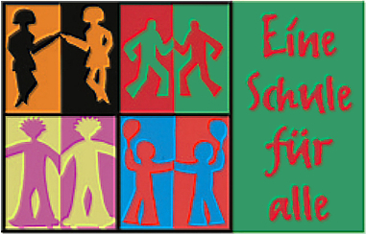
School life in Austria is very interesting. Sometimes we have six lessons a day and sometimes we have eight lessons a day. At home we spend about half an hour for studying for school.
Most pupils in our class like the subjects German, History, and P.E. most.
In our class we do lots of group works, and we must do it on our own. Most pupils in our class think that group works are okay, and the others think they are very boring.
The Visual and the Kinaesthetic learning methods help us a lot to learn things well. When we need help for school we use the internet and our schoolbooks. We also can borrow books from the school library. Most pupils think that Maths, English and History are very important for our life. Other pupils think that Music, English, Maths … and P.E. are not very important. But this is not right! Everybody needs English and Maths in life.
When we must learn and haven’t got access to internet or we can’t find information in our schoolbooks we ask our parents or our friends. We think that is better than more lessons in the afternoon because we have got so many long days and we don’t want to have more. We learn a lot in the Secondary Modern School Grünburg. We think that we spend enough time for social activities at school, because pupils get help when they need it. There are pupils who spend parts of their free-time to help other students.
Discipline has an important role for learning, because when there is no quiet in classes, you can’t learn.
A lot of us think that our school life is okay.

